**Question 1: Find the emails of students.**

Command used:

1. SELECT email FROM student;  
   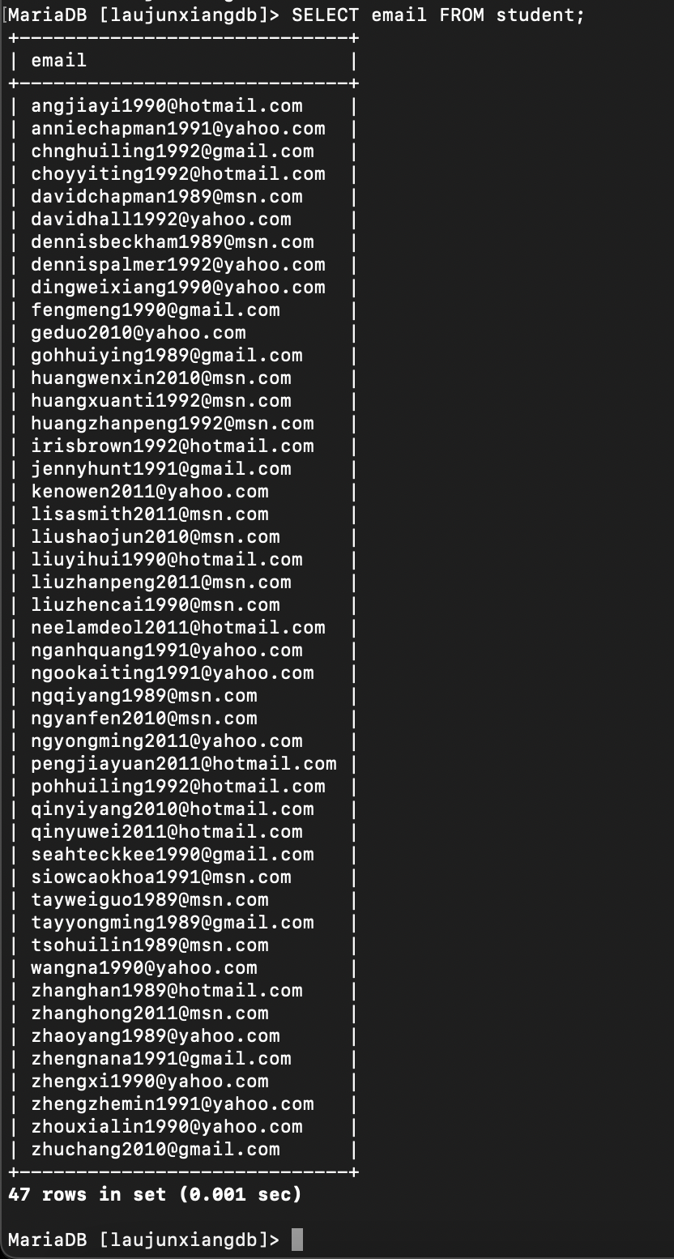
2. SELECT * FROM student;  
   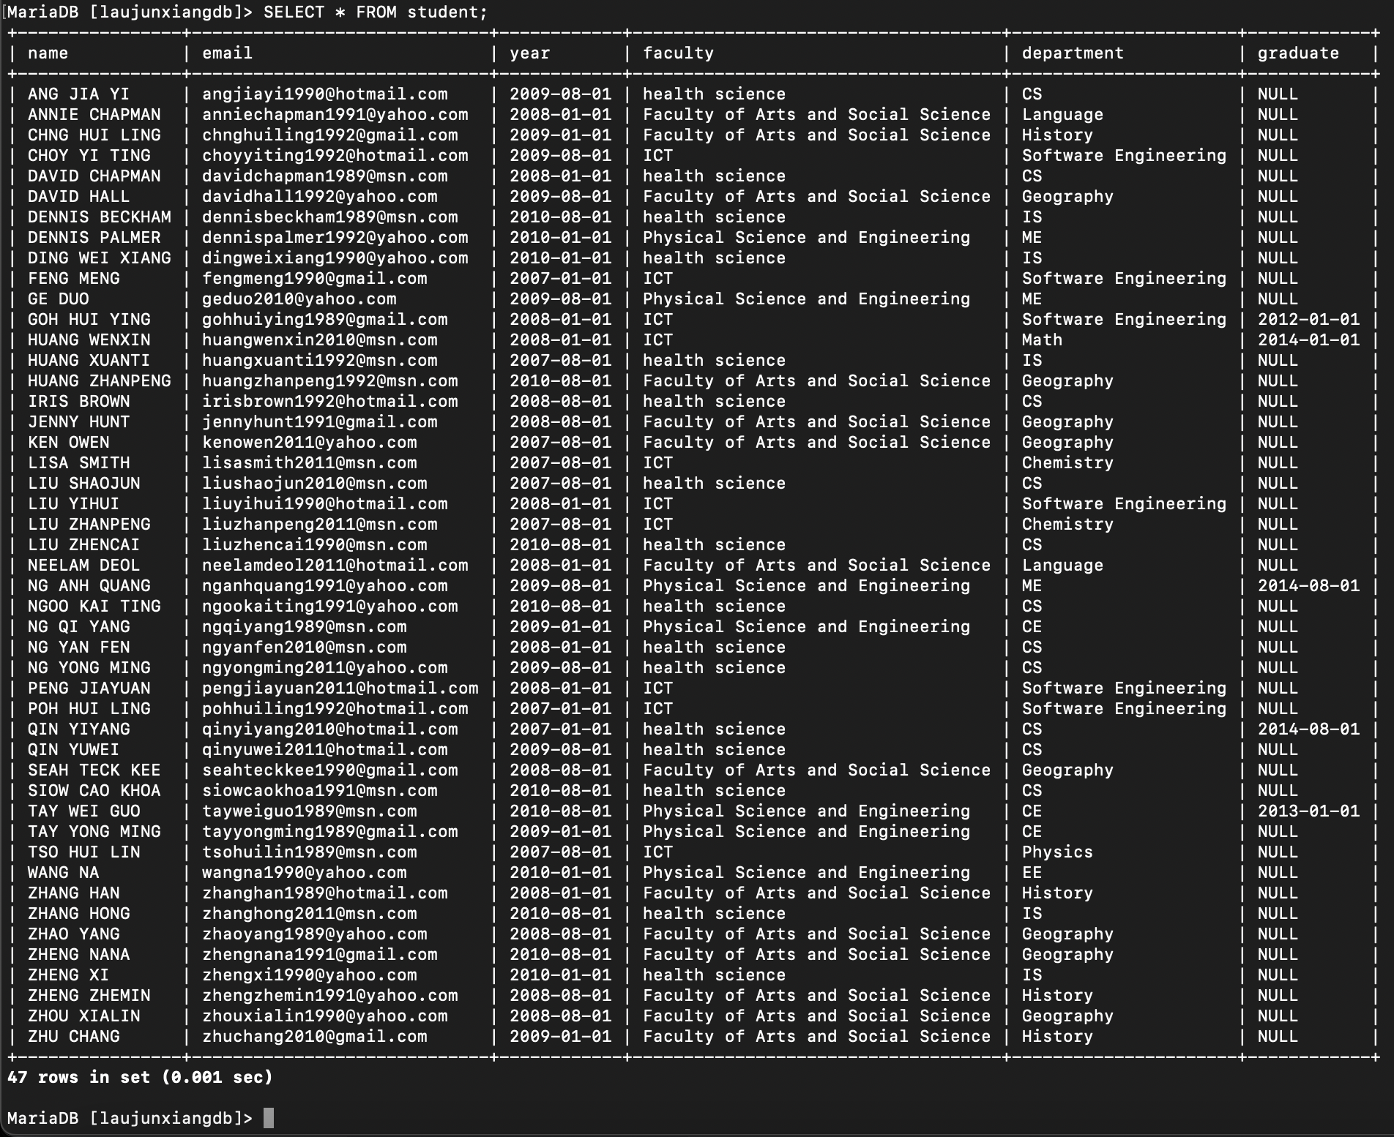

**Question 2: Find the different emails of students.**

Command used:

1. SELECT DISTINCT email, name FROM student;  
   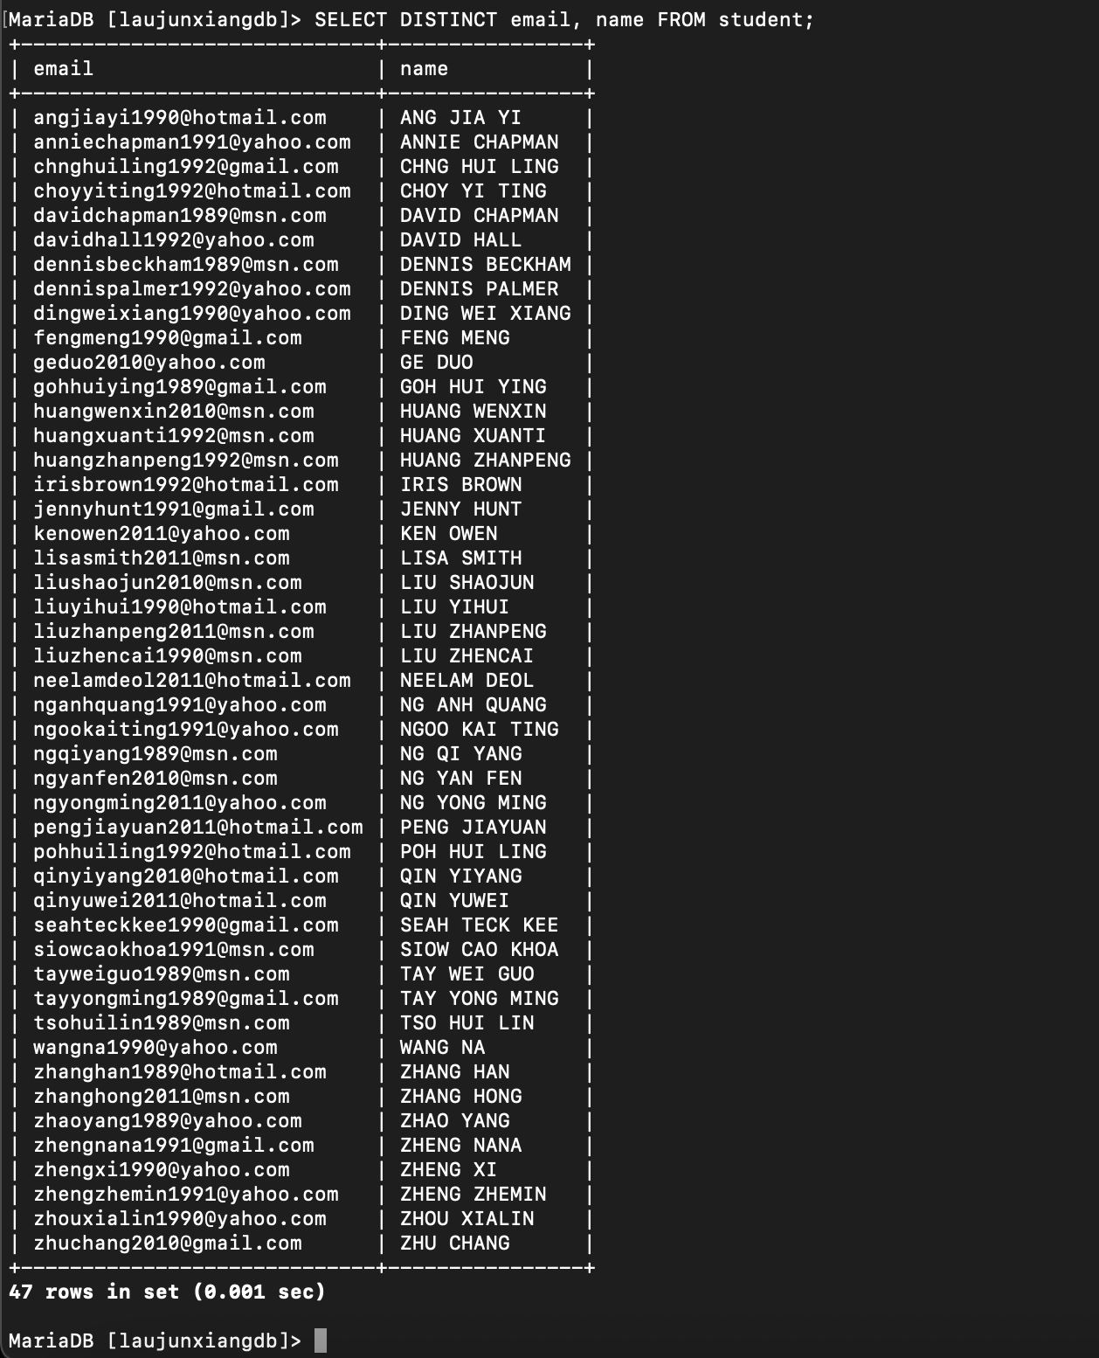

**Question 3: Print the names of students in descending alphabetical order**

Command used:

1. SELECT * FROM student ORDER BY name DESC;  
   A picture containing graphical user interface

   Description automatically generated

**Question 4: Are there students with the same name?**

Command used:

1. SELECT (COUNT(name) - COUNT(DISTINCT name)) as 'Students with same name' FROM student;  
   Text

   Description automatically generated

**Question 5: Find the different names of students; Is the result sorted? If not, please sort it.**

Command used:

1. SELECT DISTINCT name FROM student ORDER BY name ASC;  
   Timeline

   Description automatically generated with low confidence

**Question 6: Find the names of the student who owned a copy of the book ‘978-0321474049’**

Command used:

1. SELECT * FROM student s JOIN copy c ON s.email = c.owner WHERE c.book = ‘978-0321474049’;  
   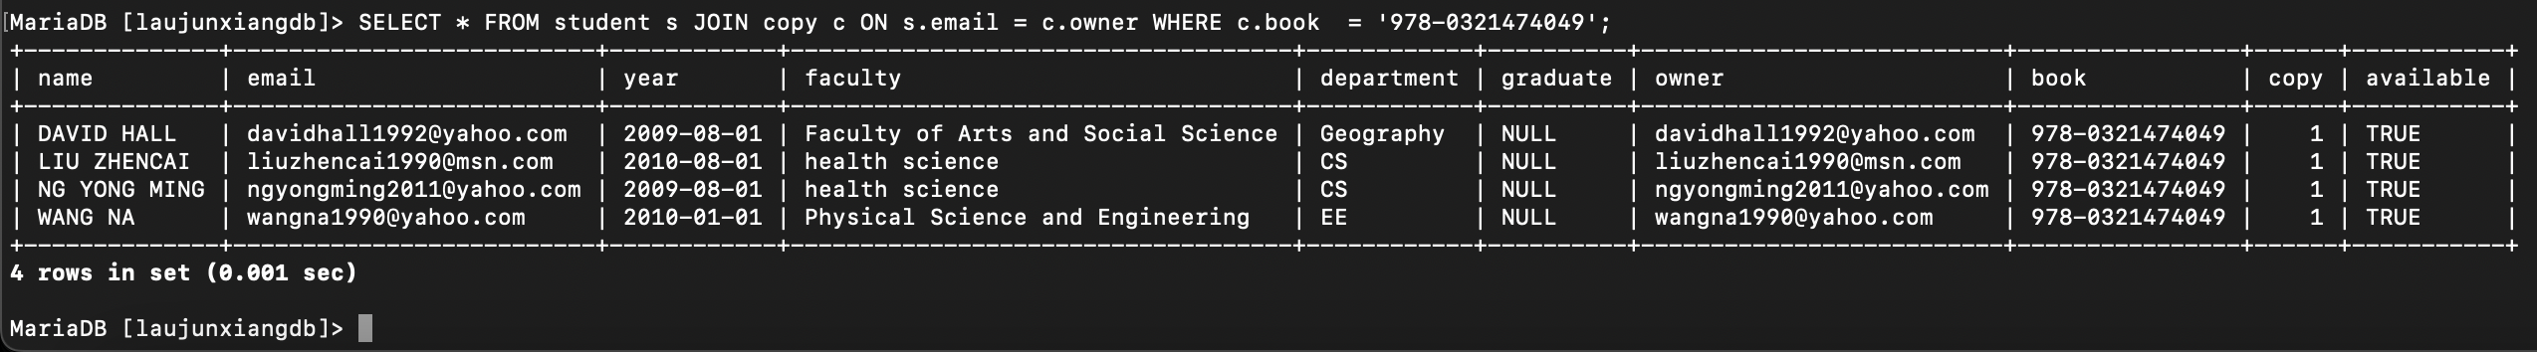

**Question 7: Find the names of the students who owned a copy of a book with more**

**than 100 pages and the book title contains the word ‘Photoshop’**

Command used:

1. SELECT s.name, b.title, b.pages FROM student s INNER JOIN copy c ON s.email = c.owner INNER JOIN book b ON c.book = b.ISBN13 WHERE b.pages > 100 AND b.title LIKE '%photoshop%';  
   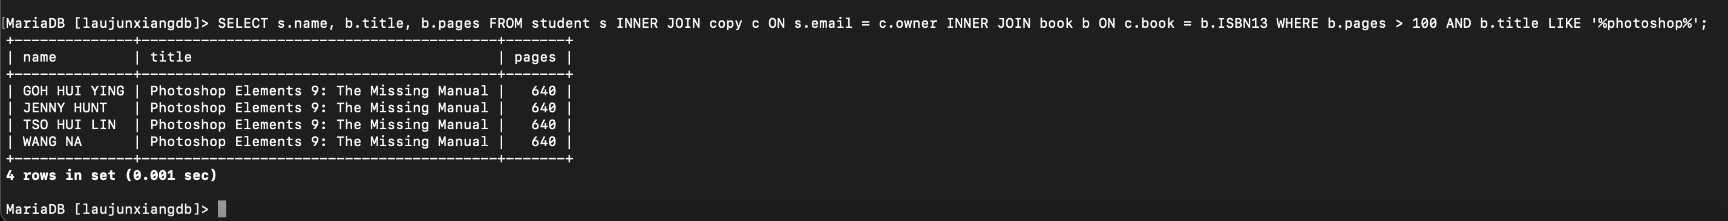

**Question 8: Find the number of A4 pages needed to photocopy the two books with**

**ISBN-13 ‘978-0321474049’ and ‘978-0684801520’ (duplex printing, or**

**2 pages of a book can be copied on one A4 page)**

Command used:

1. SELECT (SUM(pages) + 1)/2 as Pages FROM book WHERE ISBN13 = '978-0321474049' OR ISBN13='978-0684801520';  
   Text

   Description automatically generated  
   +1 to make it even number.

**Question 9: Find the different names of the students who owned a copy of a book**

**other than of ‘978-0321474049’**

Command used:

1. SELECT DISTINCT s.name, c.book FROM student s INNER JOIN copy c ON s.email = c.owner WHERE c.book != '978-0321474049';  
   Text

   Description automatically generated

**Question 10:**  **Find the names of students who borrowed a copy of the book '978-0321474049'**

Command used:

1. SELECT DISTINCT s.name FROM student s LEFT JOIN loan l ON s.email = l.borrower WHERE l.book = '978-0321474049' ORDER BY s.name ASC;  
   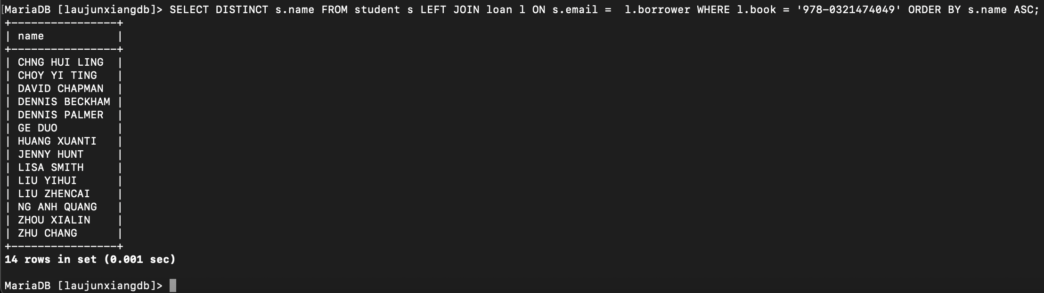

**Question 11:**  **Find the names of students who owned or borrowed a copy of the book**

**‘978-0321474049’**

Command used:

1. SELECT DISTINCT s.name FROM student s LEFT JOIN loan l ON s.email = l.borrower LEFT JOIN copy c ON s.email = c.owner WHERE l.book = '978-0321474049' OR c.book = '978-0321474049' ORDER BY s.name ASC;  
   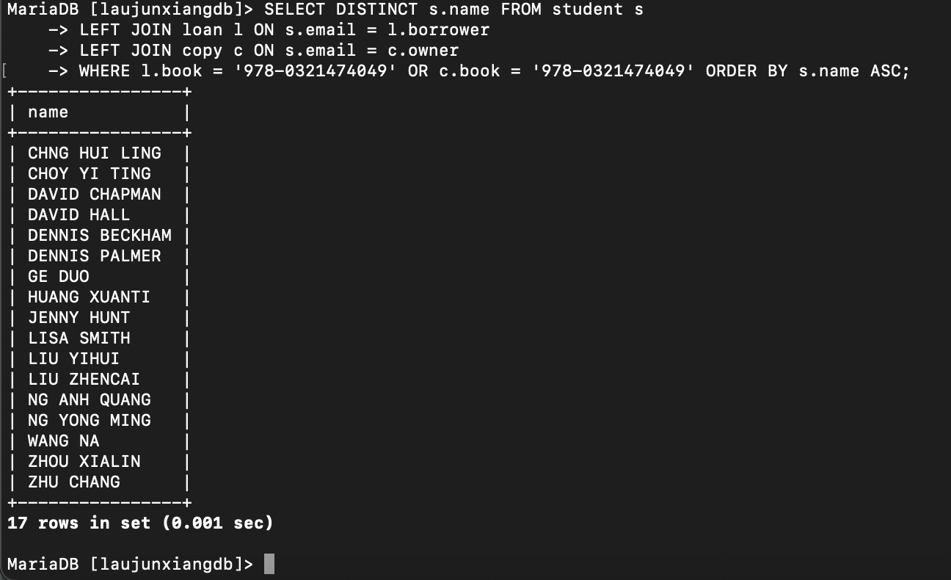

**Question 12:**  **Delete all the data in table loan.**

Command used:

1. DROP TABLE loan;  
   SHOW TABLES;  
   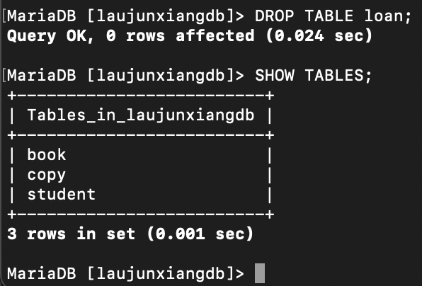

**Question 13:**  **Try the second last query again, and comment on the results.**

Command used:

1. SELECT DISTINCT s.name, l.book FROM student s LEFT JOIN loan l ON s.email = l.borrower LEFT JOIN loan k ON s.email = k.owner WHERE l.book = '978-0321474049' ORDER BY s.name ASC;
2. Laujunxiangdb.loan doesn’t exists.